Nepal College of Information Technology
Unit Test
Fall 2010
Program:BE Time: 2 hrs
Semester:Fall (I) FM: 65
Subject: Engineering Math-I PM: 32
Candidates are required to give their answer in their own words as for as practicable.

The figures in the margin indicate full marks.

Attempt all the questions.

1. a) Integrate [5]

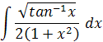
b) Integrate [5]
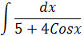

2. a) Evaluate: [5]

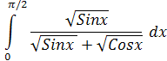

b) Find the area bounded between the parabola x²=4y and the curve y=|x| [5]
3. a) Find the approximate area using simpson's and Trapezoidal rule for
the region bounded by the curves y=x²+2, the x-axis and compare with exact value. [6]
b) Find the volume of the solid in the region in the first quadrant bounded above by the curve y=x² below by the x-axis and on the right by the line x=1 about the line x= - 1. [5]
4. a) Find by vector method the equation of the plane which passes through the points (1,1,-1) , ( 2,0,2) and (0,-2,1) [6]
b) Define scalar triple product and show that [6]
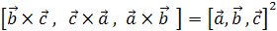

5. a) Derive standard equation of parabola y²=4ax. Find vertex, focus, axis of symmetry, directrix of the curve.

x²-2y+8x+10 = 0 [7]

b) (by summation method) [5]

6. Short question: [5x2=10]
i) 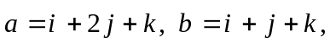 find unit vector along 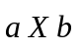
ii) Find equation of tangent at on the parabola y²=16x
iii) Find the arc length of the curve 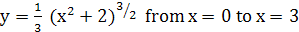
iv) Evaluate :
v) Find the vector projection of onto if -

